As we have seen how the value of hyperparameter can lead to overfitting and underfitting and as we calculated k in Knn,

Same way we can calculate Lambda here.

SO the techniques of finding best hyper parameters are called hyperparameter search or optimization.

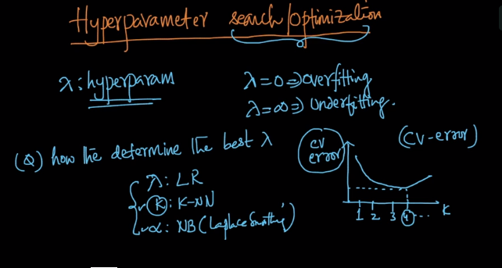

But there is one problem with Lambda, as we know K was an interger and was in limited range but lambda can take infinite range of real values.

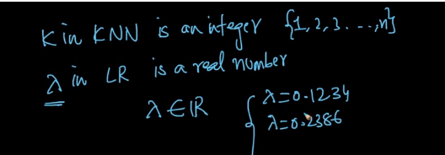

One way to overcome this problem is to Use grid search or we will refer to it as Brute Force.

In this technique we can take value in some range ,lets say {0.001,0.01,0.1,1,10,100,1000}

And then using this values we try to calculate the value of lambda and if you notice each value in set is almost 10 times of its previous value and this is how it is done in real world so as to reduce the range.

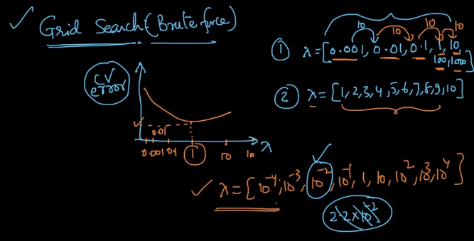

But what can we do in case of Elastic net where we have two lambda’s and how can we find it.

SO we will use same grid search technique and will apply same range and try two find CV error.

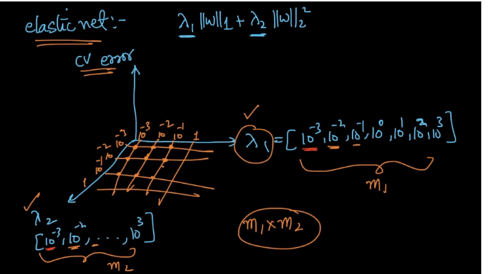

But as we can see there is big problem with hyperparameters which is as shown in below image.

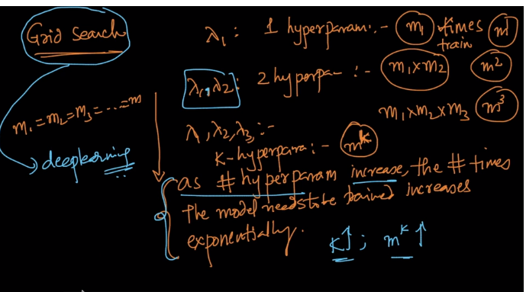

So we can see that as the number of hyperparameters increases so the number of times the model need to be trained increases exponentially.

Assuming all m1=m2=m3=… = m

And so if we have k – hyperparameters which can be even reach to hundred in deep learning.

So the number of times the model need to be trained will be equal to m^k.

So an alternative technique to random search is Random search.

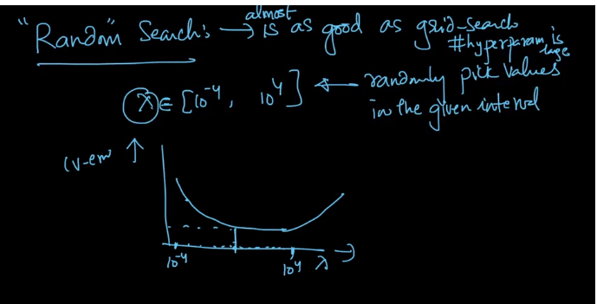

As the name suggest it just picks value randomly from the given interval and the fact is it is as good as grid search and even better in case where the # of hyperparameter is large.

And both of this can be implemented in scikit learn for any of the technique.

Comments:

